2.55: a)
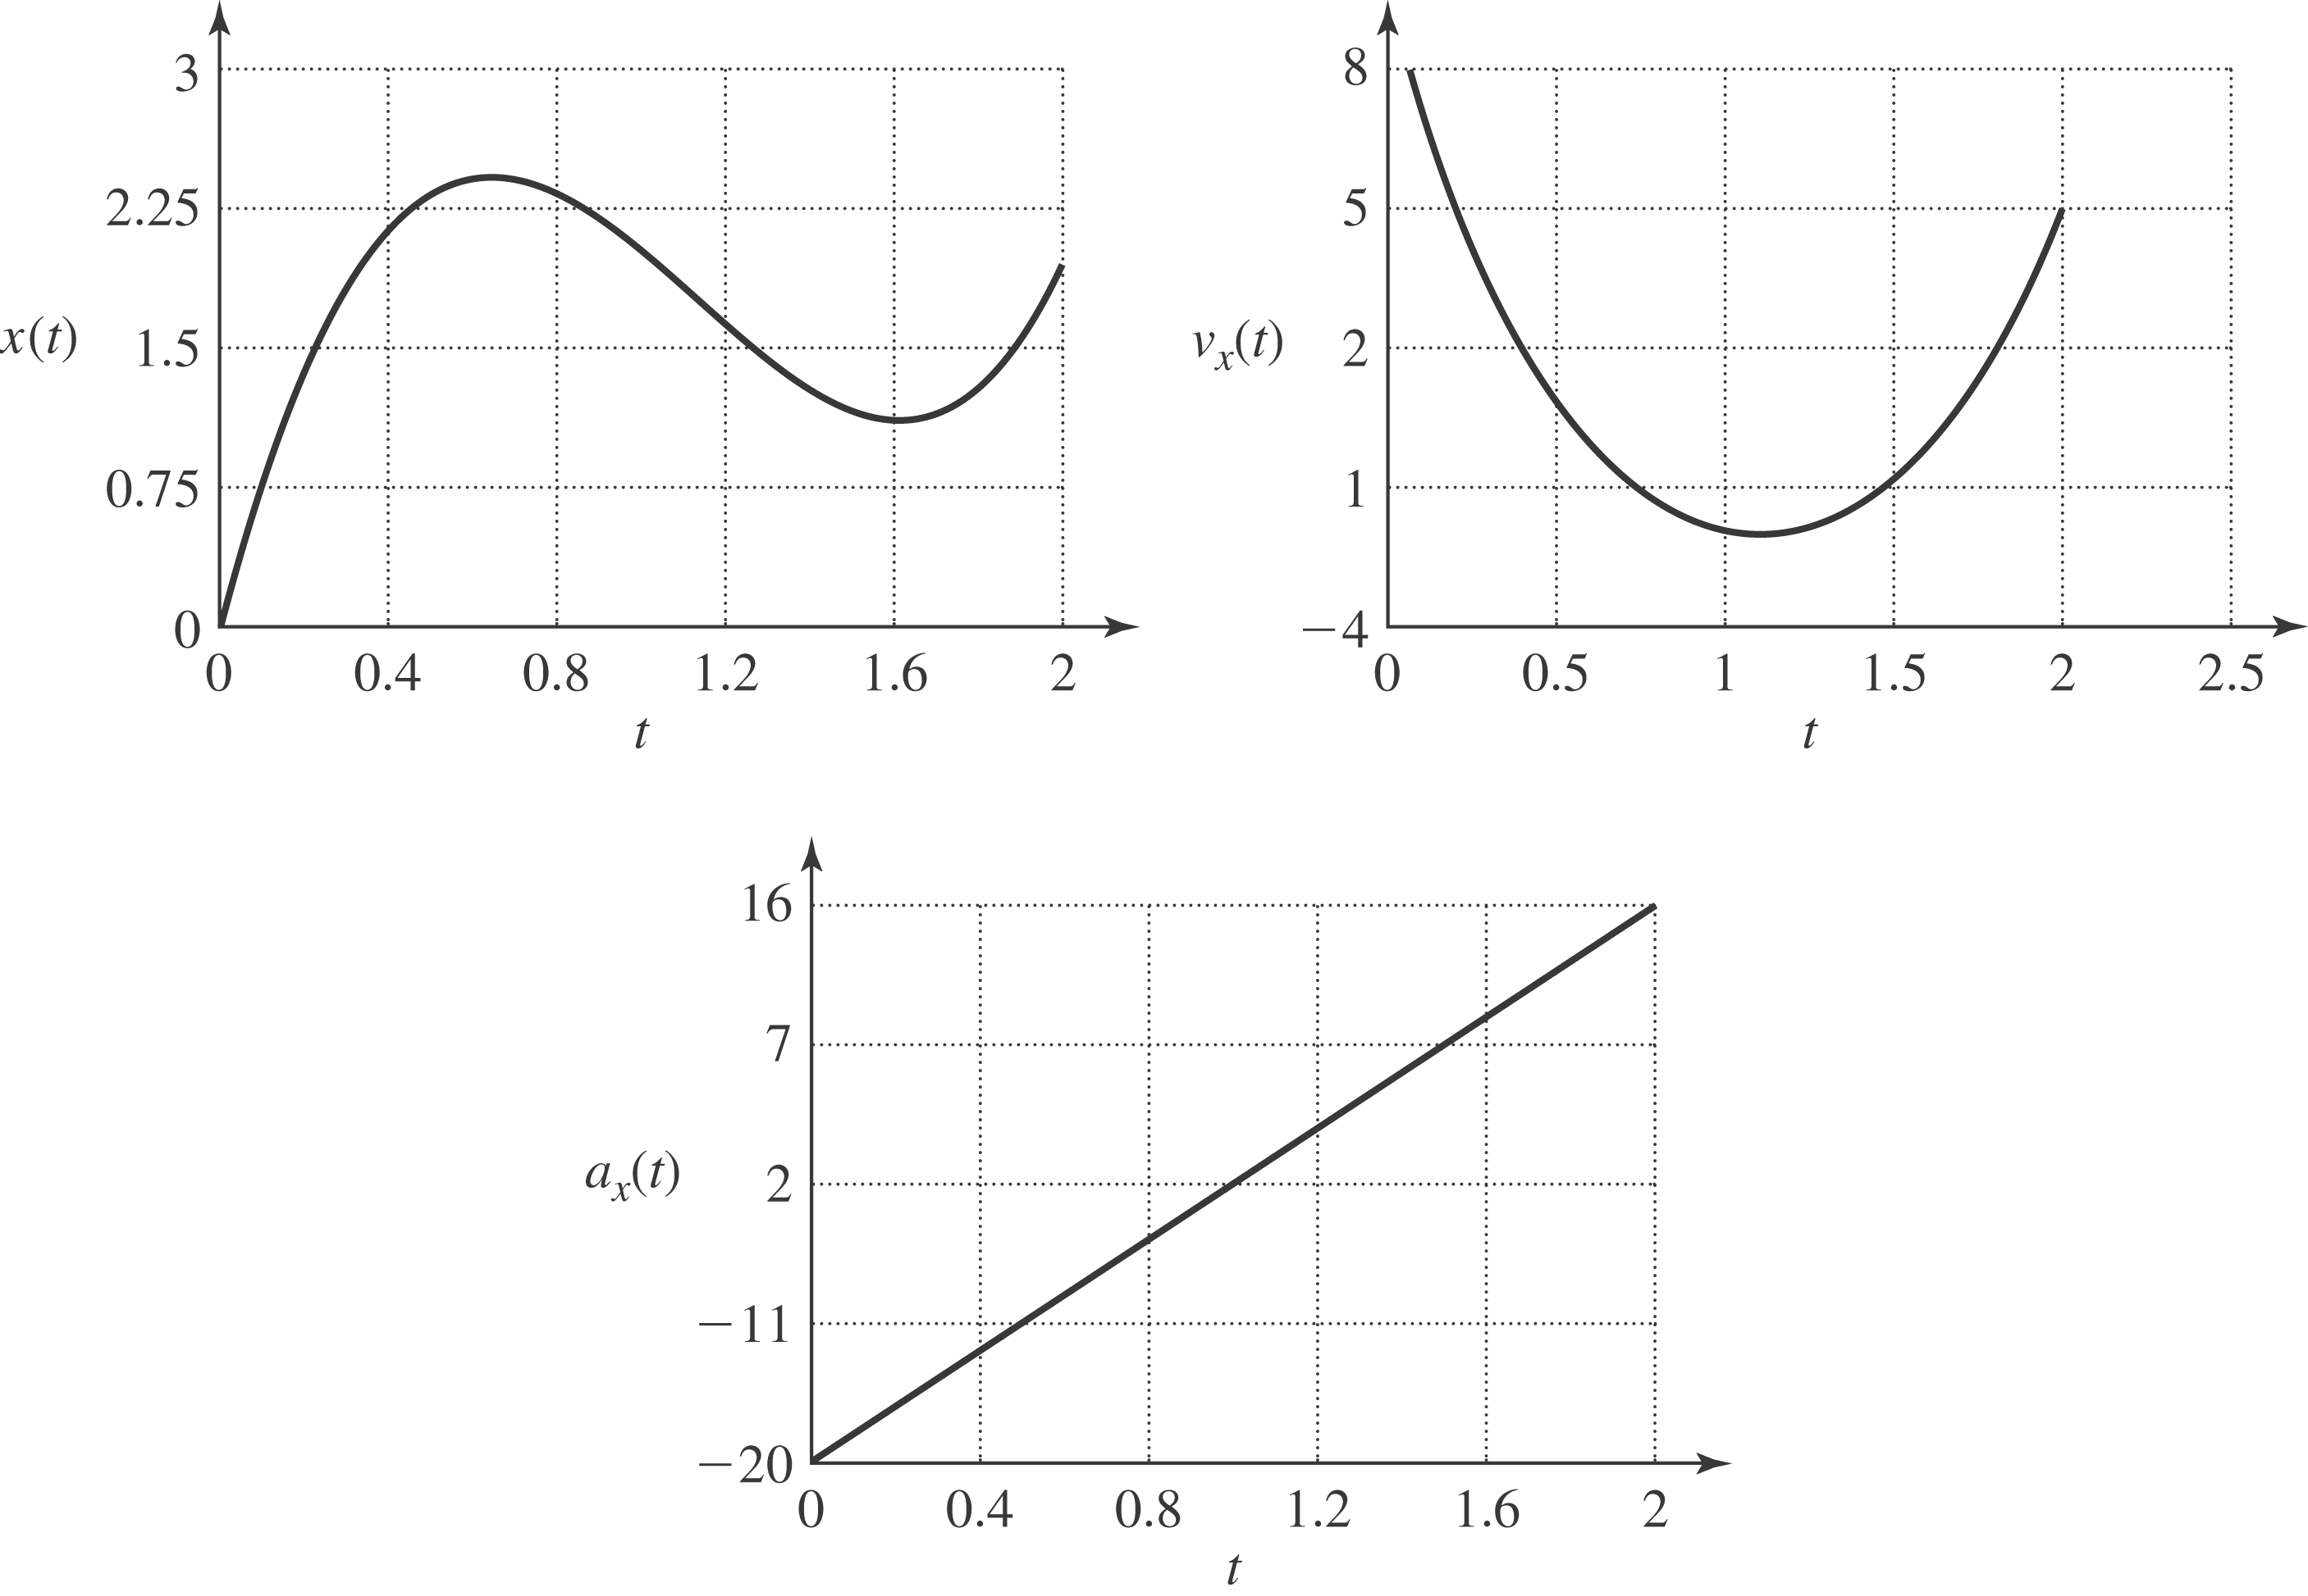

The velocity and acceleration of the particle as functions of time are

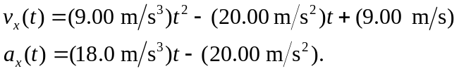

b) The particle is at rest when the velocity is zero; setting v = 0 in the above expression and using the quadratic formula to solve for the time t,

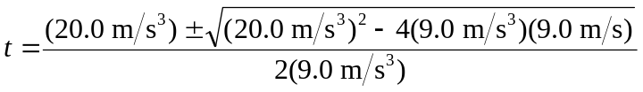

and the times are 0.63 s and 1.60 s. c) The acceleration is negative at the earlier time and positive at the later time. d) The velocity is instantaneously not changing when the acceleration is zero; solving the above expression for 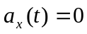 gives
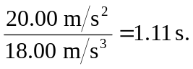
Note that this time is the numerical average of the times found in part (c). e) The greatest distance is the position of the particle when the velocity is zero and the acceleration is negative; this occurs at 0.63 s, and at that time the particle is at

(In this case, retaining extra significant figures in evaluating the roots of the quadratic equation does not change the answer in the third place.) f) The acceleration is negative at t = 0 and is increasing, so the particle is speeding up at the greatest rate at t = 2.00 s and slowing down at the greatest rate at t = 0. This is a situation where the extreme values of a function (in the case the acceleration) occur not at times when 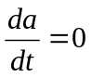but at the endpoints of the given range.

